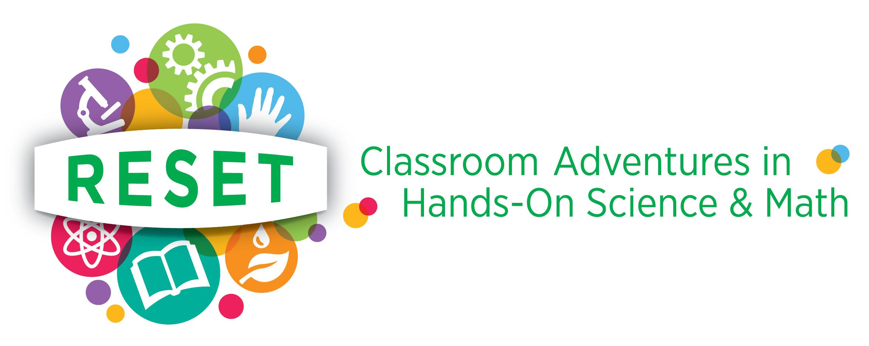
Memorandum of Agreement between RESET and (Name and address of school)

RESET and (name of school) enter into this agreement for a partnership to provide experiential science/math learning activities for and (name of school) students.

RESET is a Washington D.C.-based IRS Section 501(c)(3) non-profit organization. Its goal is to spark young students’ enthusiasm for science and math, enriching knowledge through hands-on learning, and developing relationships between students and professional scientists, technologists, engineers and mathematicians (STEM).

Program Overview:

RESET volunteers present hands-on science and math lessons in classroom settings to Pre-Kindergarten, elementary and middle school students. RESET programs include six sessions and a field trip to a STEM site with the same teacher and group of students. Schools and volunteers may agree to modify the particulars of programs, consistent with RESET and school objectives.

Partnership Responsibilities:

RESET will: recruit STEM volunteers and pair them with teachers; provide classroom skills training for volunteers; work with teachers on the content of the classroom sessions; schedule planning and organizational meetings with Principals (or designees), teachers and volunteers; pay program expenses; provide volunteer and staff contact information; and notify teachers in a timely manner of any change in the schedule of sessions.

(Name of school) will: arrange for teacher and staff participation in organizational and planning meetings; guide RESET volunteers in selection of optimal grade levels and program content; develop a classroom schedule for each teacher/volunteer pairing; ensure there is a teacher or other school official in each classroom whenever a RESET volunteer is present; provide teacher and staff contact information; notify RESET volunteers in a timely manner of any change in the schedule of sessions; and provide RESET with student and teacher evaluation forms at the completion of each program.

The signatures below signify understanding and acceptance of the provisions of this Memorandum Agreement and receipt by the signing school official of RESET Guidelines for Teachers:

Names, Signatures and Date:

For RESET: _______________________________________________Date:__________________

For (Name of
School) _______________________________________________Date:___________________

RESET Staff:
Marie Graves Marie.Graves.Reset@outlook.com or 202-607-1422
Ali Brolin alibrolin@gmail.com or 978-760-4620

