GOO!
SCIENCE

Spring 2013
At E.L. Hayes
ReSET Volunteers

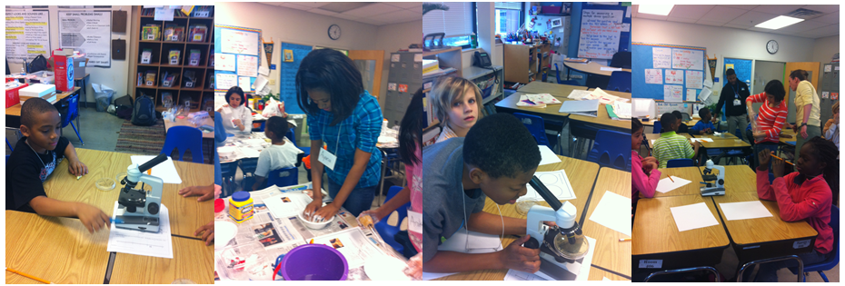

GOO!
Slimes and Polymers

What Is a Polymer?

A polymer is a substance formed from long chains of repeating units. The chains can be linked to each other. Polymers can be flexible, strong, and stretchy.

How to Make Ooblek
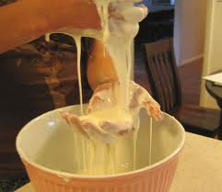
You will need:
- Water
- Cornstarch

Instructions:
- Measure out two parts cornstarch and one part water.
For example: 1 cup cornstarch and ½ cup water.
- Combine the cornstarch and water in a bowl.
- Stir, pour, roll, and squeeze the ooblek. Have fun!

Questions to think about:

- Is ooblek a liquid or a solid?
- Is cornstarch a polymer? Is ooblek a polymer?
- Can you think of other substances that behave like ooblek?

How to Make Silly Goo

You will need:
- Solution of 55% Elmer’s glue in water
- Solution of 16% sodium borate (Borax) in water
- Food coloring

Instructions:

- Mix together 4 parts glue solution with one part borax solution.
For example: 4 tablespoons glue and 1 tablespoon borax solution.
- Add food coloring for fun!
- Squeeze, roll, and stretch the silly goo. Have fun!

Questions to think about:
- Is the silly goo the result of a physical or a chemical change?
- Is glue a polymer? Is silly goo a polymer?

How to Make Flubber

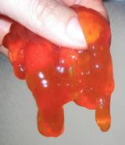
You will need:
- Metamucil or similar soluble fiber
- Water
- Food coloring
- Microwave oven

Instructions:
- Mix 1 teaspoon of Metamucil with 1 cup of water in a bowl.
- Add a drop or two of food coloring.
- Microwave on high for 4-5 minutes.
- Let the mixture cool slightly, then microwave again.
- Repeat 5-6 times.
- Pour the flubber out onto a plate and spread it out.
- Let it cool. You now have non-stick flubber!

Questions to think about:
- What are the properties of flubber?
- Does flubber stretch or bounce? Is it sticky?
- Is flubber a polymer?

GOO!
Extracting DNA
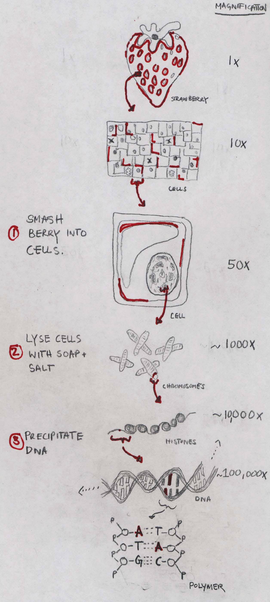

What is DNA?

Deoxyribonucleic acid (DNA) is like an instruction-book for everything that happens inside a cell. A copy of this DNA “book” is found in every living cell of every living thing. Instead of being made of paper, the instructions are made of long polymers of repeating “nucleic acids” A, G, C, and T placed on a sugar backbone “deoxyribose”. Each cell has protein machines that can read, and then carry out the instructions described in the DNA.

How to Extract DNA

You will need:
- 1 sandwich bag
- Cells (i.e. a strawberry)
- Lysis Buffer (to explode cells)
  - 2 teaspoons soap
  - 1 teaspoon salt
- ½ cup of water
- Filtering apparatus
  - Coffee filter
  - Plastic cup
- Ice cold 90% alcohol
- 1 stick

Instructions:
- Put the strawberry in the bag, seal it and gently smash it for about two minutes. This starts to break the berry into cells.
- In a plastic cup, make your DNA Lysis Buffer: mix together 2 teaspoons of soap, 1 teaspoon of salt and ½ cup of water. When added to cells, this solution will “lyse” or explode each cell, releasing its contents.
- Add 2 teaspoons of the DNA extraction liquid into the bag with the strawberry.
- Reseal the bag and gently smash for another minute. Tip: Don’t make too many bubbles.
- Place the coffee filter inside the other plastic cup.
- Open the bag and pour the strawberry liquid into the filter. You can twist the filter just above the liquid and gently squeeze the remaining liquid into the cup. This step removes any large pieces of cells that haven’t been broken down.
- Next, pour an equal amount of alcohol as there is strawberry liquid down the side of the cup. Do not mix or stir.
- Watch what happens.
- Use a stick to probe the liquid.

Questions to think about:

- After you poured in the alcohol, what did you see? Why?

- What experiments could you do with your extracted DNA?

- What is the same between the DNA you got from the strawberry and in you? Or a bug? Or a mushroom? What is different?

- How does a DNA polymer compare to the ooblek, slime, and silly putty you made last week?

GOO!
Vinegar Chemical Reactions

Egg in vinegar

Last week we dropped some raw eggs in vinegar.

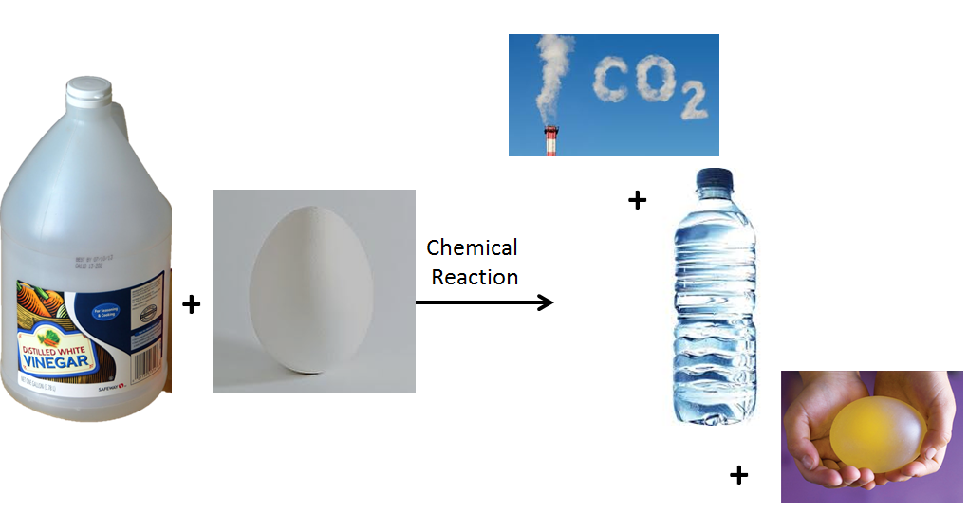
What happened to the shell?
What happened to the white?
What happened to the yolk?

Baking Soda and Vinegar Volcanoes
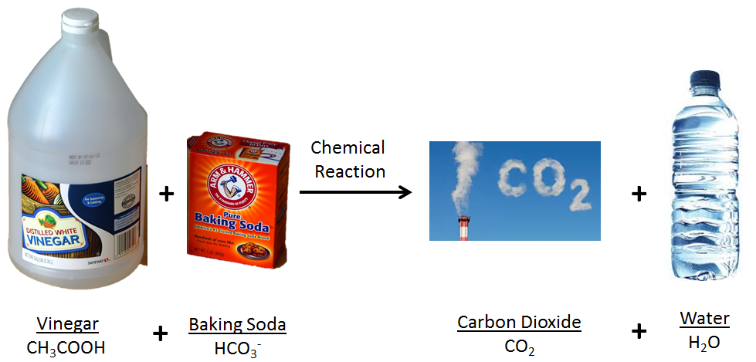

GOO!
Microorganisms and Microscopes

What are microorganisms?

Microorganisms are life forms that are too small to see by eye. They include bacteria, fungi, and viruses. Some microorganisms can make us sick, but many others are good for us! We can look at microorganisms using a microscope to magnify them.

Last week

- We collected microorganisms from different places.
- We put these microorganisms on a petri dish to grow.

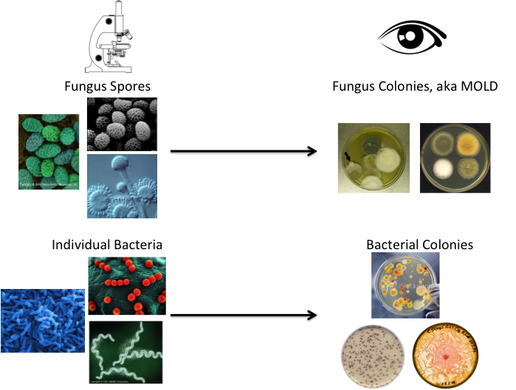
What do we see a week later?

