Seed Dissection Lab Sheet

Question: What is inside a seed? Write a hypothesis.

________________________________________________________________________________________________________________________________________________

Dry Seed Observation

- Look carefully at the pinto bean. Examine it with a hands lens.

2. Describe what you see. ________________________________________________________________________________________________________________________________________________
________________________________________________________________________________________________________________________________________________

Soaked Seed Observation

- Use a hand lens to examine the soaked pinto bean. Compare the soaked bean to the dry bean. What differences do you see?

________________________________________________________________

________________________________________________________________

- Carefully remove the outside covering of the soaked bean. Gently pull apart the two halves of the seed. Examine each half with a hands lens.

What do you inside the seed? _______________________________________

________________________________________________________________

- Draw what you see inside the bean.

- Label the parts of a seed: seed coat, baby plant (embryo), seed food (cotelydon), root, weak spot.

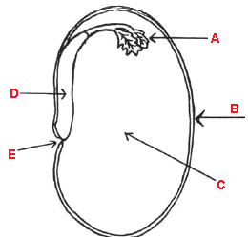

Plant Growth Lab Sheet

Question: What does a plant need to grow. Write a hypothesis.
________________________________________________________________________________________________________________________________________________________________________________________________________________________________________________________________________________________________

HOEEECseeds.doc
2/8/10

